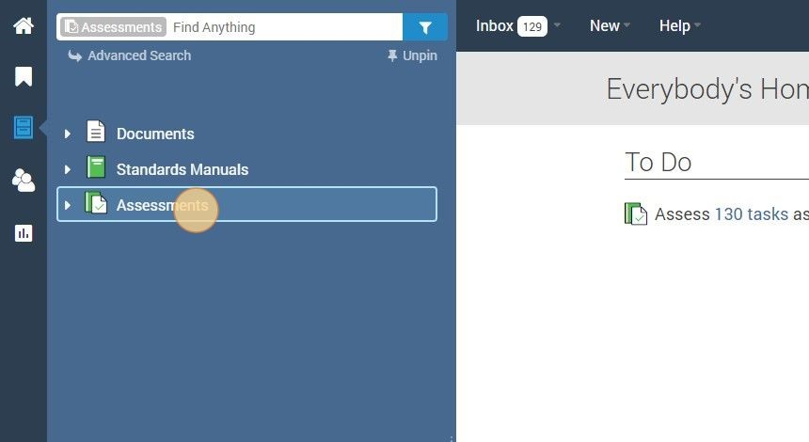
PowerDMS - Adding User to Assessment
3
Click "Assessments"
1
Navigate to https://powerdms.com/home
2 Create your new user. Then to give them access to the assessment, follow the_{following steps,}
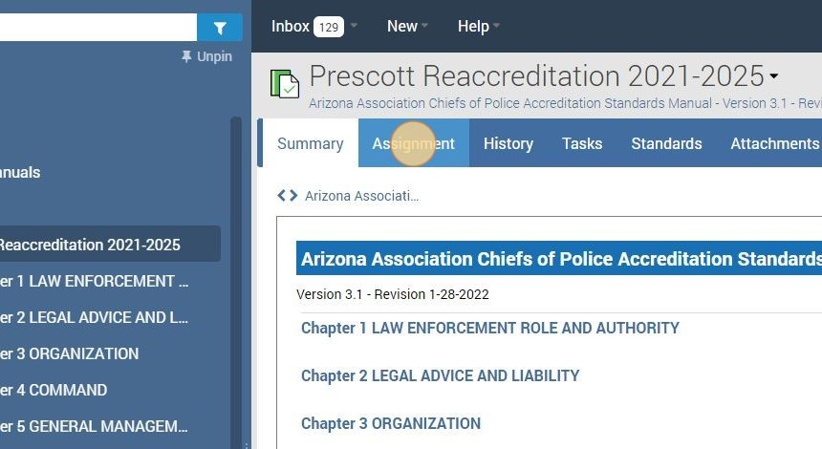
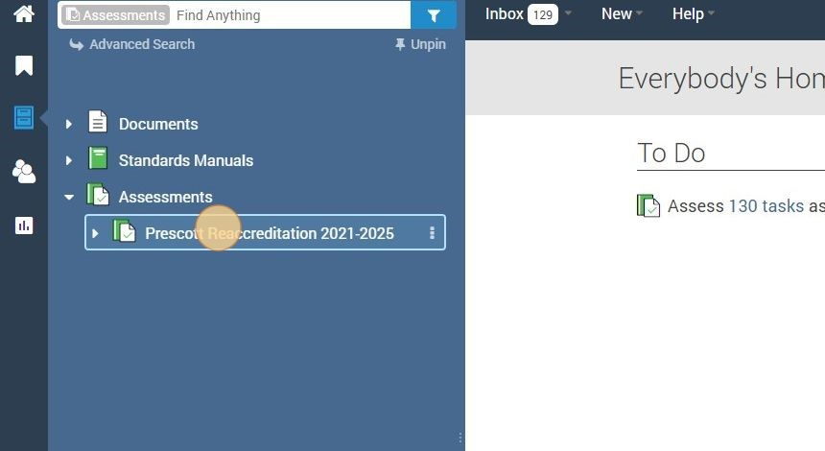
5
Click "Assignment"
4
Click on the title of your accreditation.
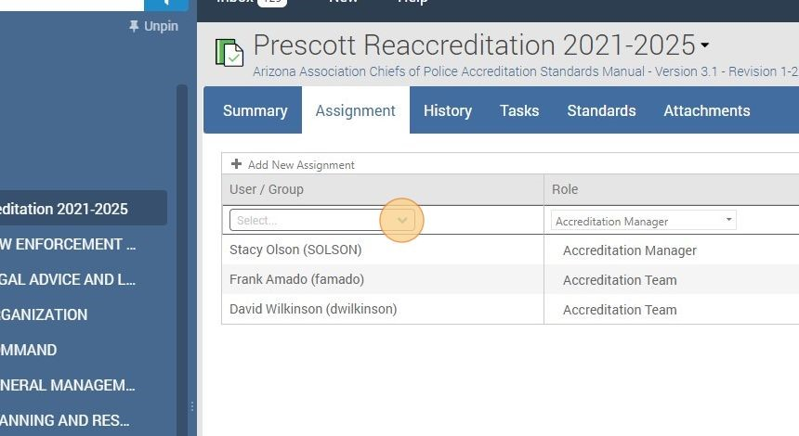
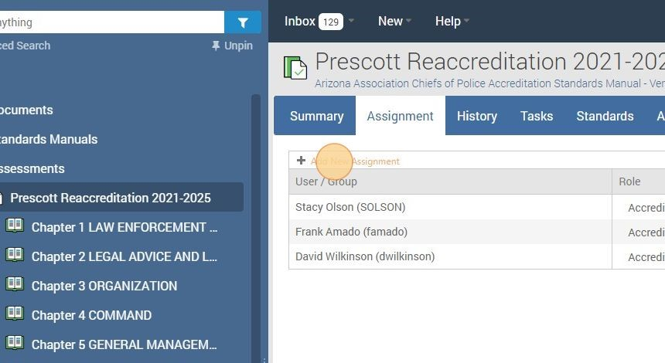
7
Click here to choose the new user you're adding.
6
Click "Add New Assignment"
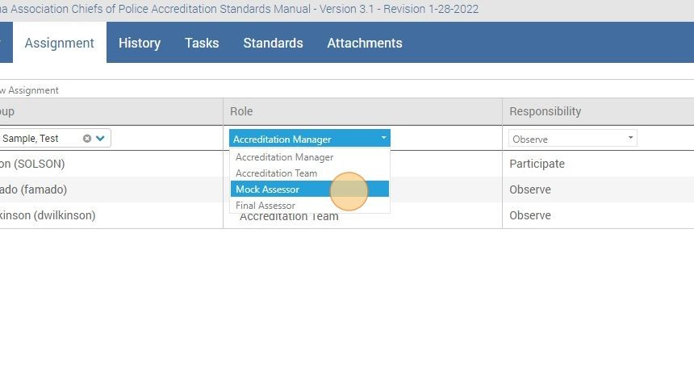
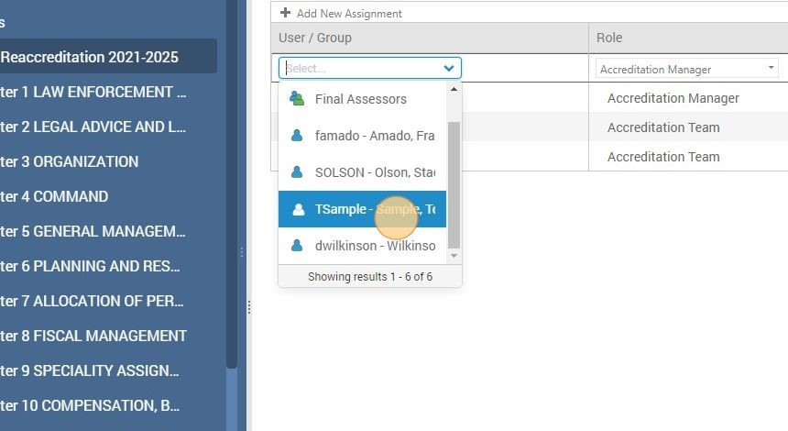
9
Click this dropdown menu to choose the users Role
8
Click here.
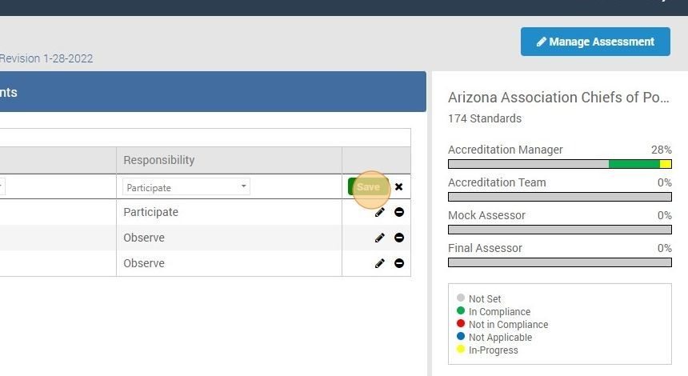
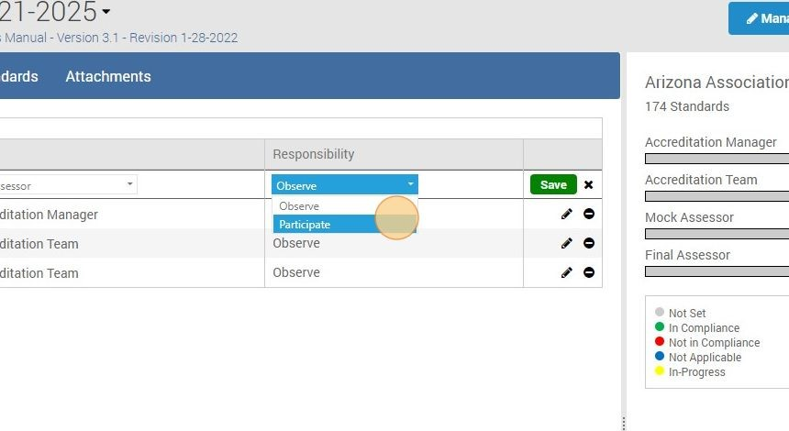
11
Click "Save"
10
Click here to choose what responsibilities the user will have.

STEP 2

Modifying Assessment Security
- To make sure the right people have the right access to your assessment, you will need to set their permissions and/or the assessment security appropriately. To modify the security of an assessment of a standards manual within PowerDMS, you will first want to navigate to the assessment you'd like to work with.
- Locate your Assessment in the blue menu sidebar menu and click the one you'd like to work with.

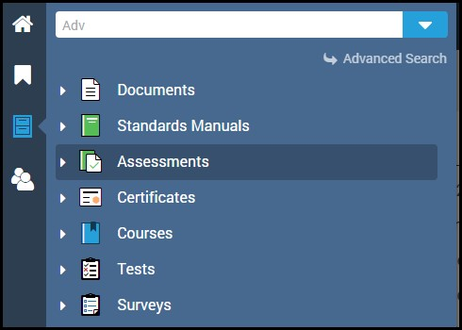

- Once you've located and opened the assessment you'd like to work with, click the blue Manage Assessment button in the top right corner, then click the Security tab.

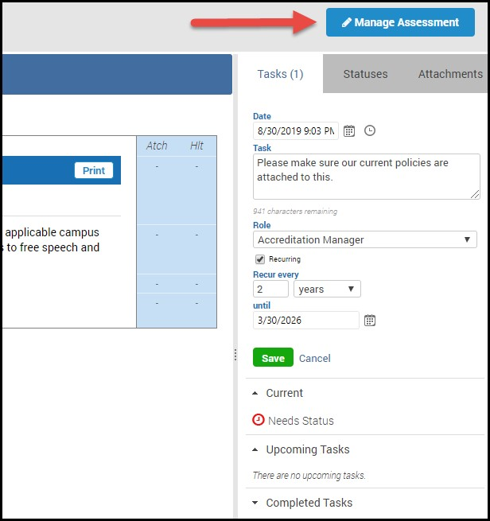

- From the Security tab of the assessment, you can grant various individuals or groups within your organization View, Audit or Edit privileges as needed. When making decisions about the security of an assessment, PowerDMS encourages administrators to be cautious when setting these privileges since many assessments contain confidential and sensitive information.

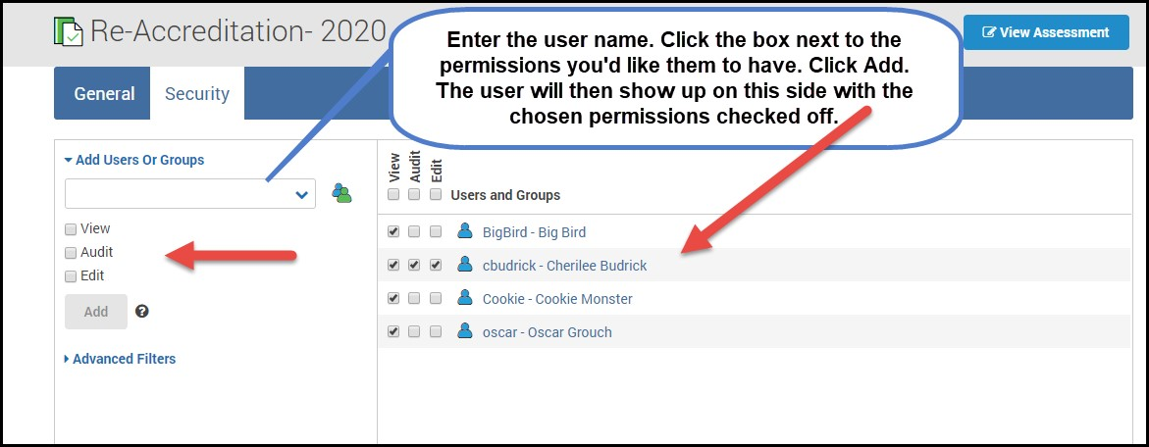

For Example:
- An Accreditation Manager's supervisor is often granted Audit rights, so he/she can run reports and check the status of the Assessment.
- The Accreditation Team is also often granted Audit rights, as they too may need to run reports on the progress of the assessment they are working on.

Table of Common Assessment Tasks and Security Rights
Needed to Complete Those Tasks

Security Right/Privilege | Allow Users to…
View | -View an assessment  -Search for an assessment  -Observe an assessment, which includes the following:  - Table of contents  - Summary  - Assignment  - History  - Tasks  - Standards  - Attachments  - Statuses  *You will need to assign users to a role within the specific standards in order for them to observe or participate in the assessment. They will only be able to see items within the role they have been assigned.
Audit  (also inherits view rights) | -View the details of an assessment:  - General Tab  - Security Tab  -Run a report on an assessment
Edit | Modify an assessment, which includes the ability to:  - Add attachments  - Set statuses on standards  - Create and complete tasks  - Assign other users to standards  - Re-order assessment attachments  - Modify an assessment’s security  - Upgrade the assessment to a new version  *You may need to give audit rights to users to assign standards and modify the assessment security.

