Creating an Approval Workflow

A document that requires approval can be sent directly via a workflow to the user or users that are required to approve it. This article will show you how to create a multi-step Approval Workflow.
SUMMARY
Briefly describe the article. The summary is used in search results to help users find relevant articles. You can improve the accuracy of search results by including phrases that your customers use to describe this issue or topic.

A document that requires approval can be sent directly via a workflow to the user or users that are required to approve it. This article will show you how to create a multi-step Approval Workflow.

CONTENT
We use Approval Workflows on documents currently in draft form that may require another set of eyes or a manager’s review and/or approval before the document is published. Workflows in PowerDMS eliminate the old-school method of passing policies from desk to desk for approval and prevents documents from getting lost in an e-mail shuffle. Instead, PowerDMS tracks all workflow steps, document changes and user comments through a structured electronic workflow within your PowerDMS site.

Setting up an Approval Workflow
- With your document open in the Document Viewer, click the three dots in the upper right corner of the window and select Start new Workflow from the drop-down menu.
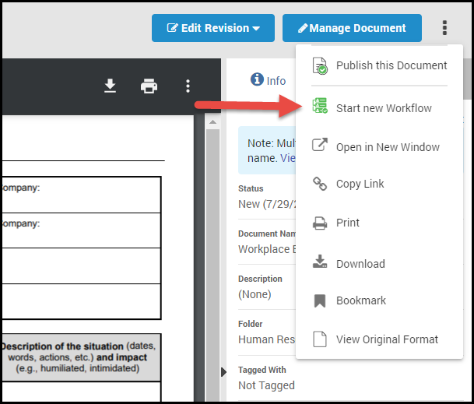
- On the next screen, you will set up your workflow.
  - Name your workflow: You may leave the Workflow Name field as the default, "Approval," or enter a more appropriate name for the workflow (e.g., "Annual Review"). Keep in mind, the name you give the workflow is what will appear as a task in the approver's PowerDMS Inbox.
  - Determine whether approvers can edit the document: If you'd like to give users in the workflow the ability to edit the document, select the Allow users to edit the draft during the workflow checkbox.
  - Define who can publish the document: If the Allow the final approver to publish this draft checkbox is selected, it means the person in the last step of the workflow has the privilege to publish this document. PowerDMS recommends that you or a trusted team member is always in the last step to ensure documents are finalized before publishing them. If you leave this option unchecked, you or a trusted team member will need to remember to go back and publish the document once the workflow is complete.
  - Log Review Lifecycle Event (optional): Many organizations have requirements to review documents on a cyclical basis. If you'd like your reviews documented, check the box next to Log Review Lifecycle Event, under the document record's Review tab, and enter any notes that should correspond with the review.
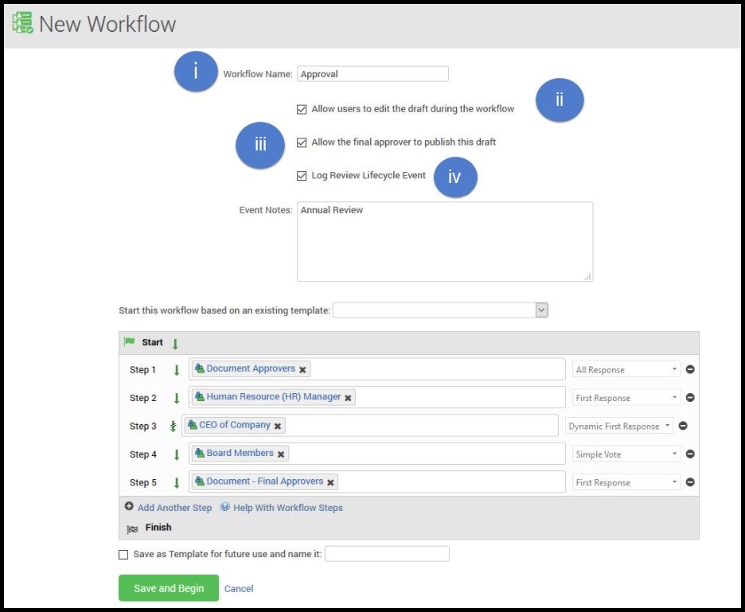
- Define your steps: Add individuals or groups to each step by typing them into the boxes; you may add multiple individuals or groups to these steps. Step 1 is the first person or group you'd like to review the document.
  - To add a step to your workflow, click Add Another Step. Add as many steps as you need.
  - To populate the steps of the workflow, at each step, start typing the names of individuals and/or groups you want to participate and click the appropriate name when it appears.
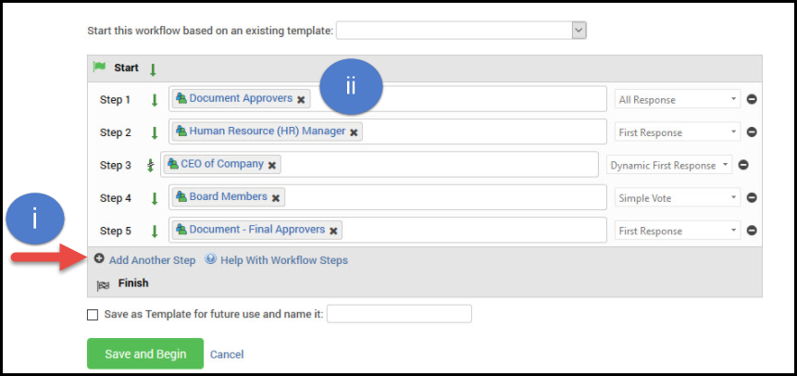
- Set your response types: After populating your workflow with users/groups, use the drop-down lists on the right to choose the response type for the step. You can click the Help With Workflow Steps button to learn about the different response types.
- Once the workflow is set up, click Save and Begin to kick off the workflow.

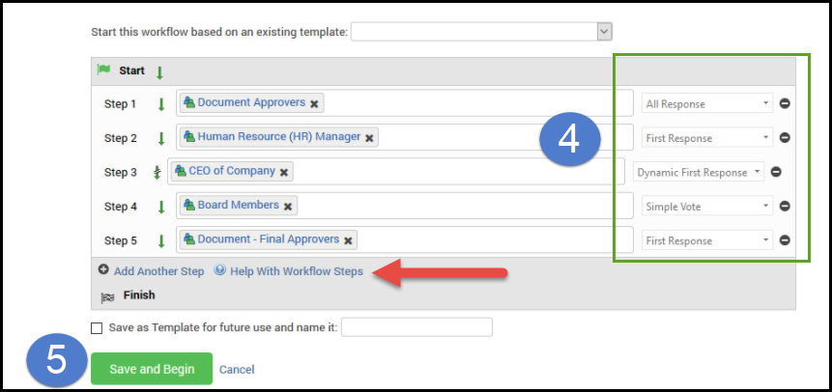
Note: While you can add both users and groups to each step, it's a recommended best practice to use groups in a workflow template. Using groups that are associated with their position in the organization rather than an individual user that may change roles helps ensure that workflows don't get stuck in the inbox of the wrong individual(s).

- The document will appear in the PowerDMS To Do list of whomever you added to Step 1. Once the user(s) approve the document, the workflow will automatically continue to the next steps/person/group.
- As the workflow Administrator, you will receive notifications in your PowerDMS Inbox after each approval/denial occurs.
​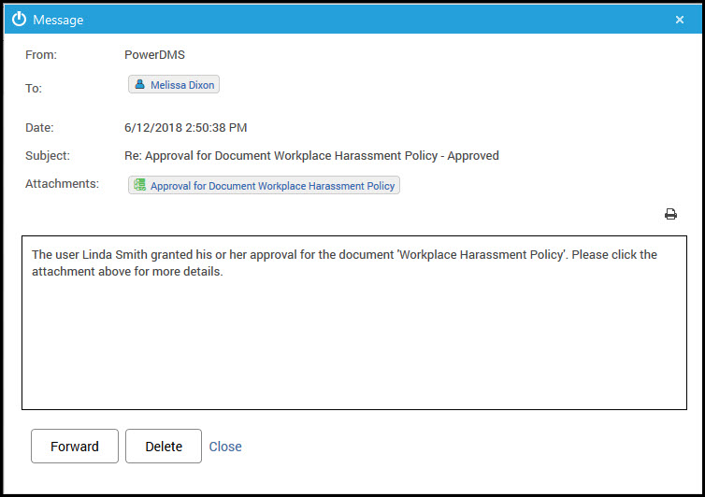
- You may click the email attachment to view the approval and any changes or comments the approver may have made.

Setting a Workflow Due Date
If you'd like to add a due date to the workflow, navigate to the document Revisions tab, Drafts subtab, and specify your desired date under the Workflow Due Date.
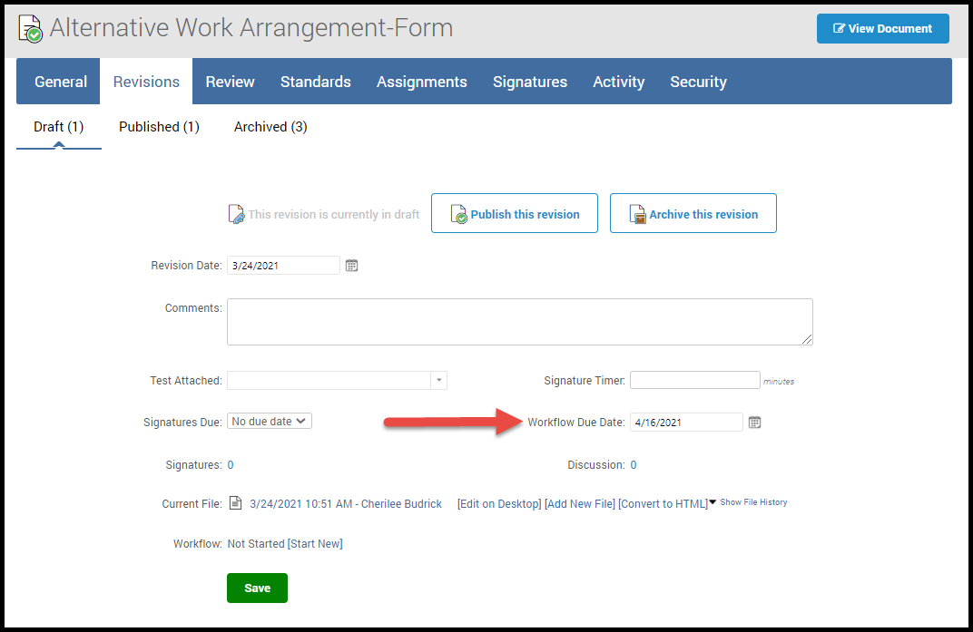
When a workflow due date arrives, it doesn't close the workflow. Instead, participants will receive notices on their To Do lists, Dashboards, and in their PowerDMS Inboxes. These reminders will come at the frequency the workflow administrator previously set.

When a Workflow has Stalled
Sometimes, workflows get held up. If for some reason your workflow is not moving along on the set timeline, as an administrator of that workflow, you have the option to skip a step and get the workflow moving again.
- Within the Workflows tab, you should see a blue arrow next to the stalled step. Click the arrow next to the step, and this will move the workflow to the next step.
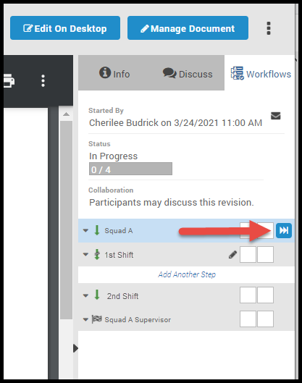
- Once you click the fast-forward icon, a window will open, indicating how many users have participated in the step and how long that step has been inactive.
- You will then have the option of typing into a text box an explanation for advancing the workflow to the next step.

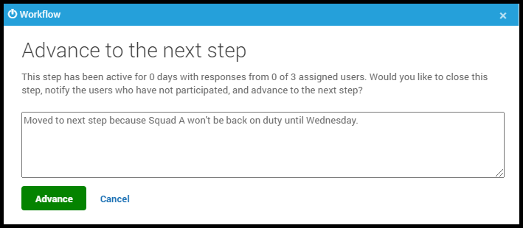
- When the workflow is advanced, all users who were skipped will receive your message in their PowerDMS Inbox that includes any comments or explanations you may have left.
- Advancing the workflow will show up in the discussion pane and on the step itself. If a comment is left in the window, it will also show up in the discussion pane.

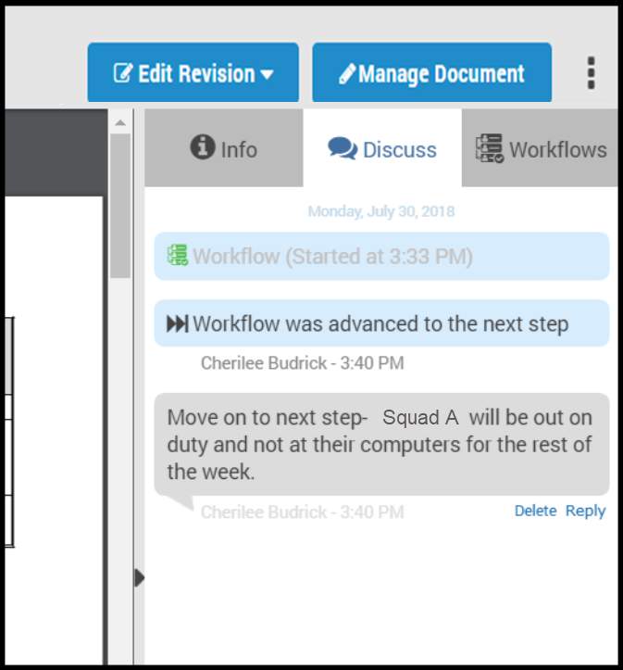
Note: This ability to fast forward through a workflow is only available for document workflows.

Making Workflow Comments Mandatory
PowerDMS Administrators can make commenting mandatory for workflow participants who deny a workflow.
- To make comments mandatory for those who don't approve a workflow, go to your Administration Menu under your name in the upper right corner of your screen.
- Click Settings, then Documents from the menu that appears.
- Check the box next to Require a comment if a Document Workflow is denied, then click Save.
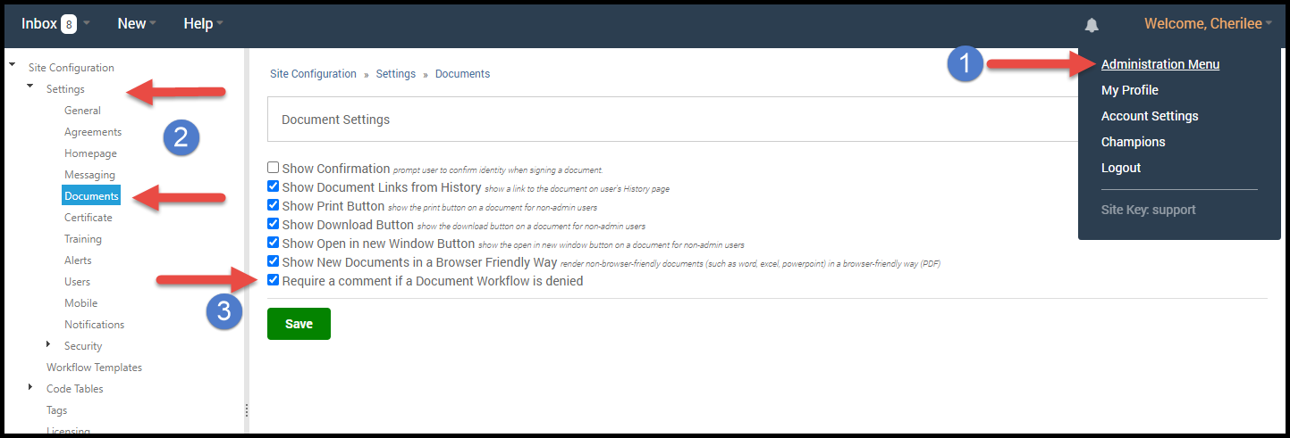

- After checking the box, workflow participants will see their approval or denial section also include an Add Explanation section that tells them In order to deny this workflow, you must provide an explanation.
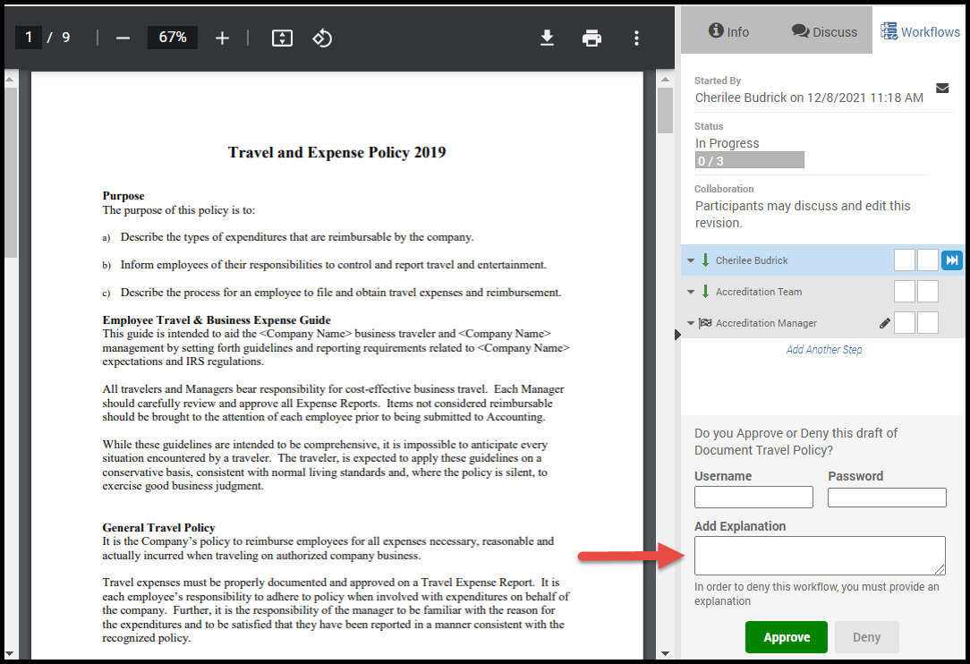
- Once the participant fills in the Add Explanation box, the Deny button will become active.
