Restoring an Archiving User

In PowerDMS, users that depart from an organization should never be deleted, but rather, archived in PowerDMS. Archiving a user account will retain all of their prior interactions with PowerDMS, which may include document signatures, training records, and certificates.
If an employee returns to your organization, you can easily restore their account by following these steps.

- From the Find Anything menu in PowerDMS, click on Advanced Search.
- Select Users from the drop-down list to the right.
- Within the Include field, toggle to Archived drop-down list, then click Search.
- Locate your user, and click the pencil icon to the right of the user record to manage the user account (if you click on the user, you will view their profile, and can then select Manage User from there)​.
- Click the Restore button.

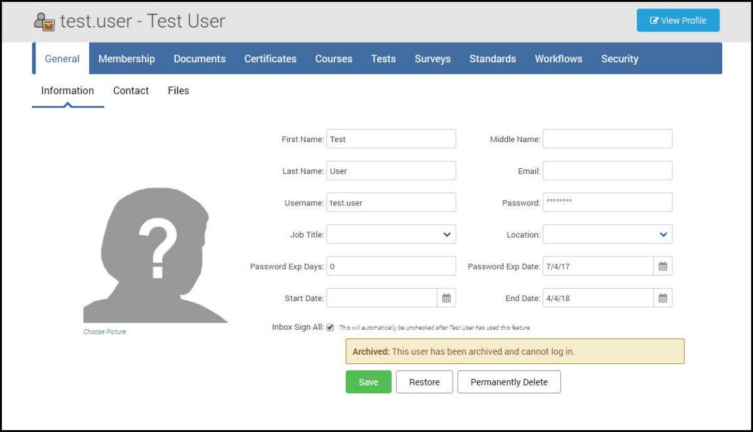
The Archived text box will be removed, and the user account is now restored in PowerDMS. You may need to reset the user's password to give them access back into PowerDMS.

