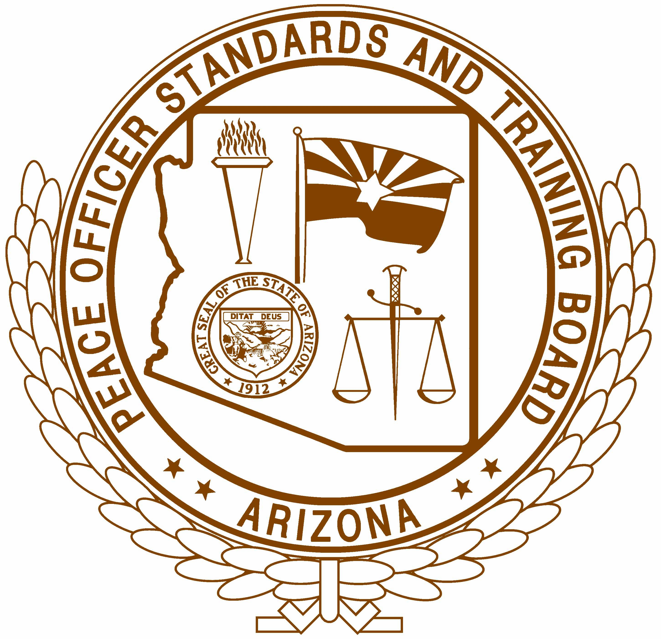
Arizona Peace Officer Standards and
Training Board

Lesson Plan

LESSON TITLE: Law Enforcement in Indian Country (LEICC)

SUBJECT: Law Enforcement in Indian Country (LEICC)

AGENCY DESIGNATION: Peoria Police Department

HOURS: 1.0

COURSE CONTENT: Overview of Tribal National Jurisdictional Authority & Procedures

PERFORMANCE OBJECTIVES:
  - Understand Tribal Jurisdiction
  - Recognize Tribal Sovereignty
  - Defining of Law Enforcement Powers Within Tribal Government(s)
  - Explanation of Judicial System (including court orders and warrants) Within Tribal Government(s)
  - Operational Parameters for Non-Tribal Law Enforcement Personnel

DATE FIRST PREPARED: September 10, 2024

PREPARED BY: Jeana Johnson, Eric Rosky & Lisa Schember

REVIEWED BY - REVISED: DATE:

REVIEWED BY - REVISED: __ DATE:

REVIEWED BY - REVISED: __ DATE:

ACADEMY DISTRIBUTION DATE: DATE:

AGENCY APPROVAL: ___________________________DATE:

INSTRUCTOR REFERENCES: PowerPoint, Policy, Judicial Code

CLASS LEVEL: Sworn & Applicable Non-Sworn Staff

TRAINING AIDS: PowerPoint

INSTRUCTIONAL STRATEGY: Briefing Training or Self-Paced

SUCCESS CRITERIA: Test

- INTRODUCTION
  - There are 537 recognized indigenous tribes within the United States.
  - Arizona has 22 tribes with the Navajo Reservation being the largest.
  - Each Indigenous tribe has its own culture, history, language, and traditions.
  - Laws, ordinances, law enforcement, etc. can be different from one tribe to another.
  - Additional facts are listed within policy 630 – Rights & Authorities of Indigenous Communities.
  - There are 3 sovereign jurisdictions in the United States:
    - Federal government
    - State government
    - Tribal government
  - Tribal governments are often considered a sovereign nation.
  - Defining Sovereign
A sovereign nation or jurisdiction is defined as a nation that has one centralized government that has the power to govern a specific geographic area.
  - Arizona Indigenous Tribes
The 22 tribes located inside the State of Arizona include:

    - Ak-Chin Indian Community
    - Cocopah Indian Tribe
    - Colorado River Indian Tribes
    - Fort McDowell Yavapai Nation
    - Fort Mojave Indian Tribe
    - Fort Yuma-Quechan Tribe
    - Gila River Indian Community
    - Havasupai Tribe
    - Hopi Tribe
    - Hualapai Tribe
    - Kaibab Band of Paiutes
    - Navajo Nation
    - Pascua Yaqui Tribe
    - Pueblo of Zuni
    - Salt River Pima-Maricopa Indian Community
    - San Carlos Apache Tribe
    - San Juan Southern Paiute
    - Tohono O'odham Nation
    - Tonto Apache Tribe
    - White Mountain Apache Tribe
    - Yavapai-Apache Nation
    - Yavapai-Prescott Indian Tribe

- LAW ENFORCEMENT AUTHORITIES
  - Many tribal governments have their own police agency that is capable of granting authority and arrest powers at a tribal, state, and federal level and are therefore capable of submitting cases to tribal, state, and federal prosecutors.
  - Eligible, trained, and qualified Indian Country police officers may also arrest cite, and release offenders or violators through the federal court system utilizing the Central Violations Bureau (CVB) citation process.
  - Tribes or communities with Indian Country jurisdiction inside the State of Arizona may have a tribal or community constitution that establishes their police department and defines police powers. The established police departments may have AZPOST-certified and/or federally sworn police officers.
- LOCAL JURISDICTION
  - The Peoria Police Department borders the property of the Desert Diamond Casino, which is owned by Tohono O’odham Nation. The property is located at 9431 W. Northern Ave, Glendale, AZ 85305-1104.
  - No Memorandum of Understanding exists between the Peoria Police Department and the Tohono O’odham Nation as of September 2024.
  - The Tohono O’odham Nation Police Department has law enforcement authority and jurisdiction over their property and calls for service are dispatched through the Tolleson Police Department.
  - The Tohono O’odham Nation Police Department’s jurisdiction is:
    - South of Northern Ave
    - North of Orangewood Ave
    - West of 91st Ave
    - East of L-101
    - Appx. 158 acres or 0.25 sq. miles

- WARRANTS & COURT ORDERS
  - Many tribal governments have courts that issue warrants and orders warrants and their law enforcement agencies have:
    - the authority and powers to arrest and serve.
    - the authority to enter into ACJIS and CJIS systems.
  - Court orders issued from a tribal government shall be treated the same as one issued from another state unless it is entered into an Arizona repository (i.e. AZPOINT) at which time it will be processed the same as an order or warrant issued from an Arizona agency.

- ARREST & SEARCH WARRANTS
  - Arrest Warrants
    - Arrest warrants should be confirmed with the issuing agency and then detainment and/or arrest will be determined based on that agency’s response and availability.
  - Search Warrants
    - If it is deemed that a search warrant is necessary to be carried out on tribal land, officers shall contact the applicable tribal law enforcement agency before applying for a search warrant. It will need to be determined if a search warrant issued from a non-tribal court will be accepted or if the search warrant will be required to be issued through the tribal court.
    - No search warrant conducted on tribal land shall be done without the full knowledge and permission of the applicable tribal law enforcement agency.
    - If a tribal law enforcement representative contacts the Peoria Police Department to assist with the service of a search warrant within department jurisdiction, personnel shall work to assist and guide the tribal representative(s) with the highest level of professionalism.

- MUTUAL AID AGREEMENTS
  - Many tribal governments have mutual aid agreements, memorandums of agreement (MOA), memorandums of understanding (MOU), and/or inter-governmental agreements (IGA) with both non-tribal and other tribal governments.
  - The Peoria Police Department does not currently have any written agreement with the Tohono O’odham Nation.

- EXTRADITION PROCESSES
  - It shall be recognized that many tribal governments have extradition processes to and from Indian Country jurisdiction and state jurisdiction.
  - Extraditions and these warrants can be entered by the Indian Country jurisdiction tribal law enforcement agency into ACJIS and CJIS systems
  - Personnel shall respect extradition requests to/from a tribal law enforcement agency the same as any other law enforcement agency and seek to verify that extradition policy and/or procedures are available.

- EXCLUSIONARY RIGHTS
  - Many tribal governments have exclusion processes from Indian Country jurisdiction of persons whose presence is detrimental to the peace, health, or morals of their community or who violate the laws of their community.
  - Eligible, trained, and qualified Indian Country jurisdiction police departments may also arrest, cite, and release such offenders or violators through the federal court system utilizing the Central Violations Bureau (CVB) Citation Process.

- DOMESTIC VIOLENCE (VAWA)
  - A person suspected of violating the law, USC Title 18, Section 2261, shall be detained pending consultation with a federal agency on whether they shall be taken into custody. The subsequent protocols shall be followed:
    - No person shall be detained any longer than legally permitted. If a federal agency advises that they will take custody of the suspect, but a transfer of custody will not take place for an extended period, with supervisor approval, the:
      - Detained person may be transported to a detainment center with a hold placed, or
      - Be transported to the applicable federal agency set to take custody.
      - A supervisor shall retain the right to refuse the transport of a detained person if the expected distance or time for transport places undue stress on the department.
      - If a federal agency fails to respond or be contacted in a reasonable time, and no other state or local offenses exist to warrant an arrest, the person shall be released from custody.

- MISSING OR MURDERED INDIGENOUS PERSONS (MMIP)
  - Established with the Savannah Act of 2020
  - To assist in combating this, personnel who become aware of a victim, of known or believed indigenous descent, shall attempt to identify the tribe membership of the victim and give notification to the applicable tribal law enforcement agency that a possible victim has been found.
  - If assistance is requested by the tribal agency, personnel shall make a reasonable effort to accommodate and assist where possible for reunification.
  - If a crime is being investigated by the Department, then personnel shall have the right to deny requests that may compromise the integrity of said investigation.

- OPERATIONAL PARAMETERS
  - Peoria Police Department officers do not have law enforcement authority on tribal land, this includes Desert Diamond Casino property.
  - Officers are permitted to assist the Tohono O'odham Police Department if authorized by the department.
  - If assistance is needed from the Tohono O'odham Police Department or any other tribal law enforcement agency, contact communications to coordinate.

- REFERENCE INFORMATION
  - Contact Numbers (also found in policy)
    - Tohono O’odham Nation Police Department – (520) 383-3275
    - Tolleson Police Department – (623) 936-7186 ext. 1
  - Federal/State Laws & Codes can be found in policy.
  - Policy: 630 – Rights & Authorities of Indigenous Communities

Conclusion
Upon the completion of this training, officers should:
  - Understand about tribal jurisdiction and their capabilities and limitations.
  - Understand about tribal sovereignty and what functionality sovereignty offers to tribal nations.
  - Be able to describe the abilities of a tribal law enforcement agency and how to support tribal law enforcement.
  - Know the parameters of operation in and near a tribal government and how to collaborate with tribal law enforcement agencies when needed

TEST QUESTIONS
- What tribal jurisdiction does the Peoria Police Department border?
  - Navajo Nation
  - Tohono O'odham Nation
  - Ak-Chin Indian Community
  - Gila River Indian Community

- Which type of the following is a sovereign jurisdiction within the United States?
  - Federal Government
  - State Government
  - Tribal Government
  - All the Above

- Tribal law enforcement officers can be AZPOST certified and/or federally certified.
  - True
  - False

- The Northeast corner of the Tohono O’odham Nation property that borders the Peoria Police Department is located at:
  - Happy Valley Rd & Lake Pleasant Pkwy
  - Northern Ave & 91st Ave
  - Glendale Ave & 99th Ave
  - Bell Rd & 75th Ave

- Officers must receive approval from the department to request assistance from tribal law enforcement officers.
  - True
  - False

- Tribal governments are not authorized or able to issue warrants or court orders.
  - True
  - False

- Officers may serve a warrant on tribal lands whenever needed without notice to the local tribal law enforcement agency.
  - True
  - False

- The business located on the Tohono O’odham Nation property is:
  - Gila River Resorts & Casinos – Vee Queva
  - Queen of Hearts Casino
  - Desert Diamond Casino – West Valley
  - Casino Arizona

- The corresponding policy to this training is:
  - 1000 – Law Enforcement in Indian Country
  - 213 – Tribal Nations of Arizona
  - 630 – Rights & Authorities of Indigenous Communities
  - 423 – Tribal Rights of Law Enforcement

- Officers can access both applicable laws and contact numbers within department policy?
  - True
  - False

