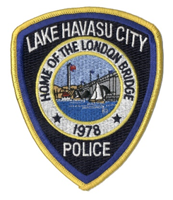
Lake Havasu City Police Department
Troy Stirling
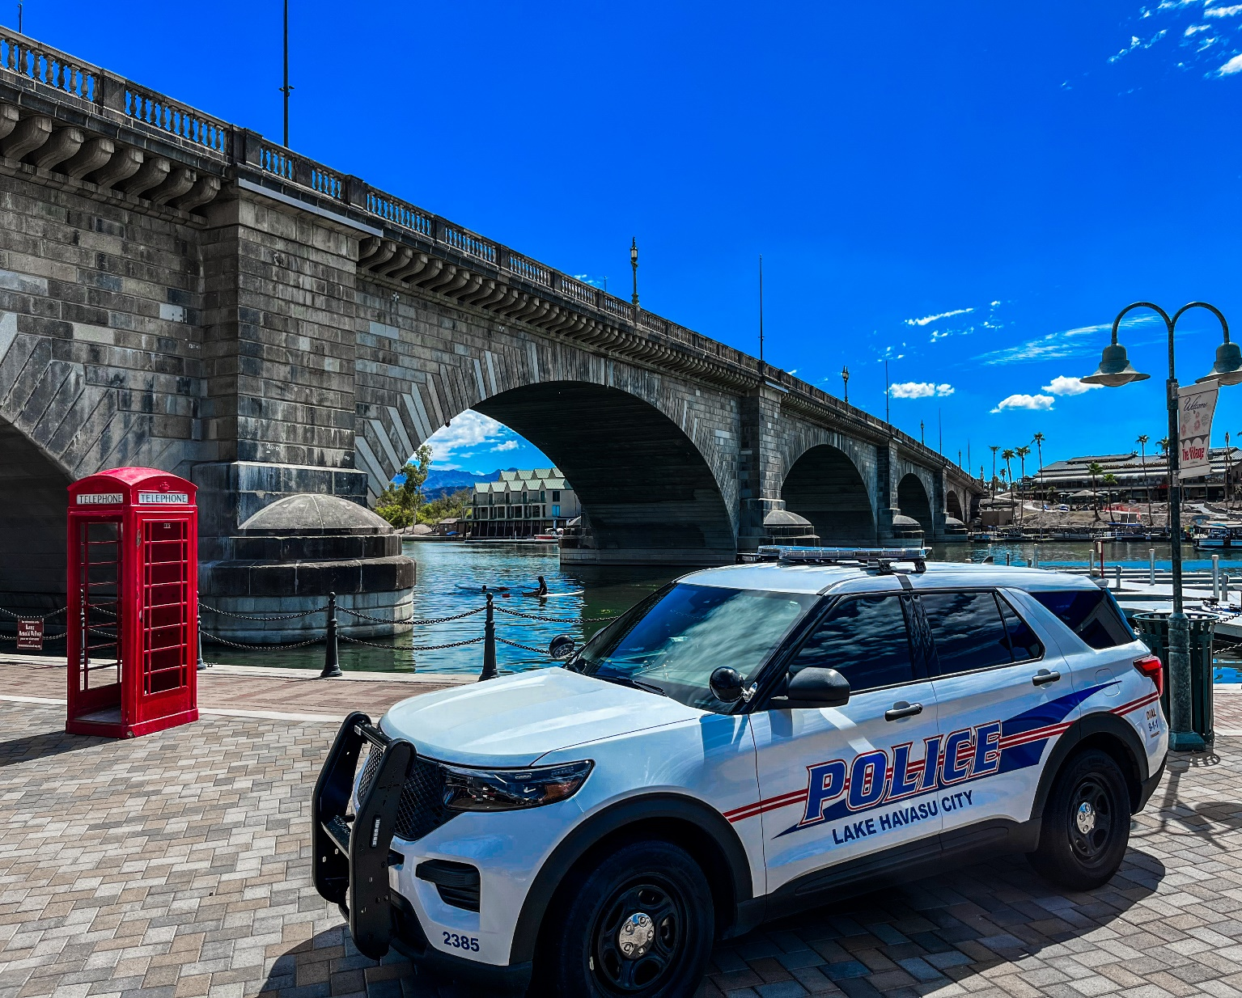
Chief of Police
ALEAP Assessment
January 3-4, 2024
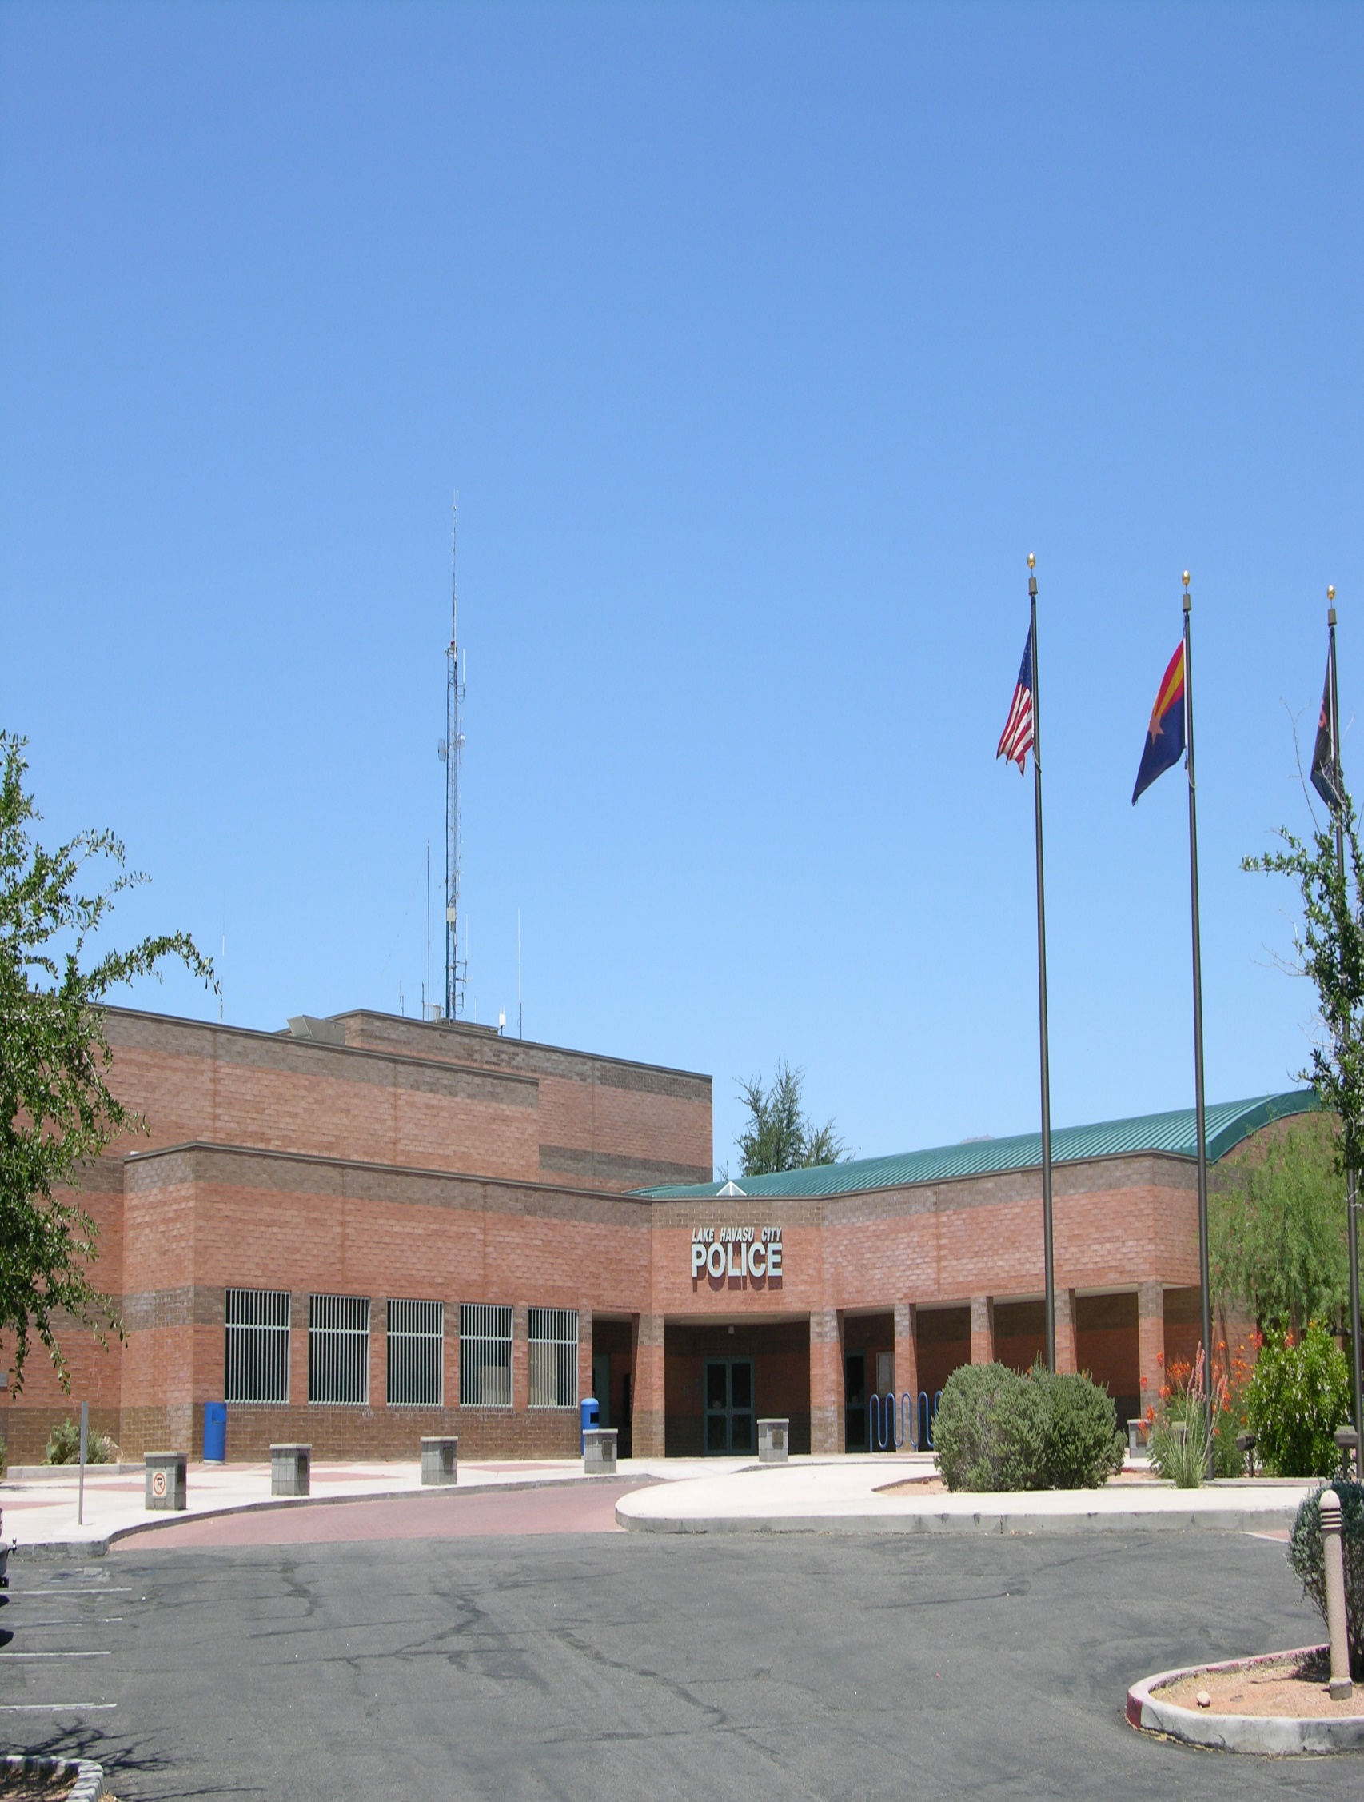

Welcome to LHCPD

On behalf of Chief Troy Striling and the LHCPD staff, it is a pleasure to welcome you to Lake Havasu City and LHCPD. We hope that your stay will be interesting, enjoyable, and informative. I hope you will have an opportunity to view our city’s icon, the London Bridge, during your stay.
If there is anything that you need at any time during your visit, please do not hesitate to contact me.

Lieutenant Chad Williams
LHCPD Accreditation Manager

Here are some telephone numbers that may be beneficial to you during your visit:
Lt. Chad Williams Chief Troy Stirling
928-230-6201 cell 928-680-5421 office

Cpt. Kirk Cesena Cpt. Doug Whittaker
928-680-5452 office 928-680-5416 office

LHCPD Assessor Work Area
2360 N. McCulloch Blvd. 928-854-0803
928-855-1171

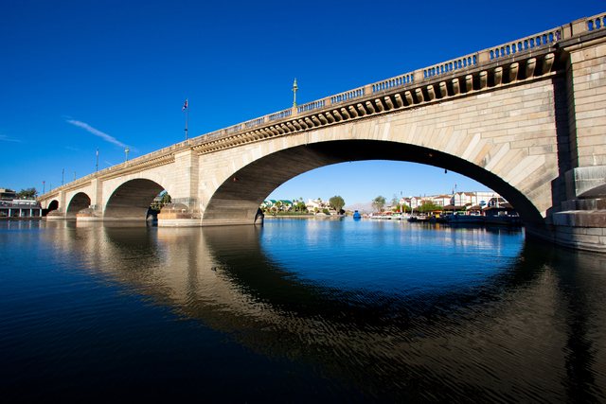

Our Mission Statement
Ensure a safe and secure community

Our Vision
To be recognized as a leader in the law enforcement profession

Our Principles
Each member of the organization is committed to professionalism and to the following principles in carrying forth the mission of the Lake Havasu City Police Department:
Integrity as a foundation for all actions
Partnerships with our community
Dedication to our community and the organization
Accountability to the public
Maintaining open communication
Valuing the individual employee
Efficiency through innovation

LHCPD Executive Staff
Troy Stirling, Chief of Police
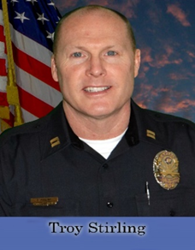
Chief Troy Stirling joined the Lake Havasu City Police Department in 1997, after serving almost 3-years with the Mohave County Sheriff’s Office and promoted through the ranks to the Support Division Captain in 2016. During his 25-year law enforcement career, he has worked as a supervisor of the Criminal Investigations Unit and the Professional Standards Unit. In 2015, after being promoted to Lieutenant, he was assigned as the Academy Commander for the Western Arizona Law Enforcement Training Academy where he oversaw the academy operations until being promoted to Captain in 2016. As the Support Division Captain, he oversaw the Professional Standards Unit, Records Unit, Jail Unit, and the Communications Center until being selected as Chief of Police in December of 2022.

Chief Stirling holds a bachelor’s degree in criminal justice with a concentration in supervision and management from Herzing University which he obtained in 2015 and is a 2018 graduate of the 271st session of the FBI National Academy.

Chief Stirling currently serves as the Treasurer for the Western Arizona Law Enforcement Association. He and his wife, Kim, enjoy volunteering their time with various community organizations and they have a 23-year-old son and a 32-year-old daughter.

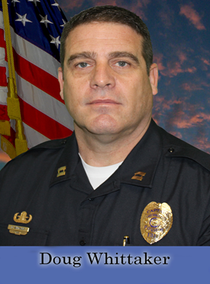
Doug Whittaker, Support Division Captain

Captain Doug Whittaker started his Law Enforcement career in 1989 with the Mohave County Sheriff’s Office before joining the Lake Havasu Police Department in 1997. During his 34+ year career in Law Enforcement Captain Whittaker has been involved in almost every area within the Department. Captain Whittaker has worked in Patrol and Investigations including Special investigations as a Detective, Investigations Supervisor, and Investigations Lieutenant. In patrol he also held positions as a Boating Officer, Patrol Sergeant, and Patrol Lieutenant. Captain Whittaker also spent almost 17 years as a member of the Departments SWAT team with 7 of those years as the SWAT team commander. He also was the Bomb Squad commander for over 12 years and a Bomb Squad member for over 15 years. Captain Whittaker was promoted to Sergeant in 2002 and Lieutenant in 2007 before taking on his current rank, Captain in 2014. After working 1 year as the support services Captain overseeing the Budget, Jail, Dispatch, and Records. Captain Whittaker took over the Departments Operations Division from 2015 until November of 2021. He has since returned to the role in Support Services. Captain Whittaker spent four years in the United States Marine Corps prior to his law enforcement career and graduated from the FBI national Academy class 238 in 2009. Both of Captain Whittaker’s daughters were born and raised in Lake Havasu City and he has been married to his wife Tonya for over 35 years.

Kirk Cesena, Operations Division Captain
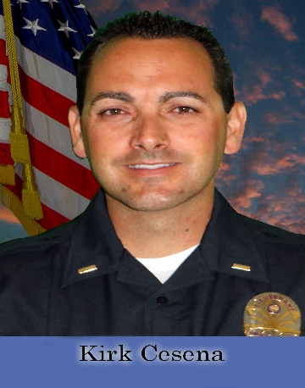
Captain Kirk Cesena started his law enforcement career in 1999 with the Los Angeles County Sheriff's Department before joining the Lake Havasu City Police Department in 2006. During his 24-year career in law enforcement, Captain Cesena worked in corrections, patrol, Street Crimes Unit, and patrol Corporal. Captain Cesena was promoted to sergeant in 2015 where he worked patrol and later supervised the Professional Standards Unit. In 2016 Captain Cesena was promoted to Lieutenant where he supervised the dayshift patrol division, which also included the Traffic Unit, Community Services Unit, School Resource Officers, and the Animal Control Unit. In 2021, he was assigned to oversee the Professional Standards Unit and the Western Arizona Law Enforcement Training Academy. He was promoted to the rank of Captain in 2022 where he currently serves as the Operations Captain. Captain Cesena holds a Bachelor of Science Degree in Economics and is a 2021 graduate of Northwestern School of Police Staff and Command Class #510. Captain Cesena enjoys off-roading, camping, sports, grilling, and spending quality time with his family. He and his wife Kimberly have two sons, ages 14 and 16.

ALEAP Assessment – Schedule
(Subject to Change)

Day 1 – Wednesday, January 3, 2024

9:00 – 9:30 Introduction to LHCPD Command Staff
LHCPD Admin Conference Room

9:30 – 10:00 Interview with Chief Troy Stirling
Chief’s Office

10:00-10:45 Department Tour-Escorted by Captain Kirk Cesena & Lieutenant Chad Williams

10:45 – 11:00 Site Inspection with Sergeant Tom Gray
Property and Evidence

11:00 – 11:15 Interview with Records Unit Supervisor Robin Shoemake
Admin Conference Room

11:15 – 11:30 Site Inspection with Records Supervisor Robin Shoemake
Records Unit


11:30 -1:00 Lunch: Blue Chair

1:00 – 1:30 Interview with Management Analyst Stefanie Morris
Admin Conference Room

1:30 – 1:45 Interview with Professional Standards Unit Sergeant Mike Terrinoni
Admin Conference Room

1:45 – 3:00 Assessors work time.
Admin Conference Room

3:00 – 4:00 Public Call-in Session
Admin Conference Room

4:00 – 5:00 Ride Along with Officer TBA

5:30- 7:00 Dinner: Shugrue’s

Day 2 – Thursday, January 4, 2024

9:00 – 9:30 Assessors work time
Admin Conference Room

9:30 – 10:00 Interview with Operations Captain Kirk Cesena
Admin Conference Room

10:00 – 10:45 Interview with Dispatch Lead Deven Nutt
Interview and site inspection in 911 Communications Center

11:00 – 12:00 Interview with Human Capital Management Director, Dr. Bobbie Kimelton
Interview and site inspection at City Hall

12:00 – 12:30 Assessor work time
Admin Conference Room

12:30 – 1:00 Exit interview with Chief Troy Stirling and Captain Kirk Cesena
Chief’s Office



Department Tour

Records Administration
Communications Support Building
Briefing Room Training Room/Council Chambers
Technology Room Jail-Booking areas
Armory Report Writing
Investigations Weight Room
Property & Evidence Locker Rooms
Evidence Submission Interview Rooms

Observable Standards

6.3 Mission Statement-briefing room
18.9 Records
26.1 Records Integrity
26.2 Personnel Files (HR/RM)
27.5 Storage and Security (P&E)
27.6 High Risk Storage (P&E)
28.2 Communications Services
28.5 Portable Radios
28.6 Recording
28.8 Security of Communications Center
29.1 Blood Borne Pathogen Standards – Bullet B PPE Provided

Not Applicable Standards

7.1 Reserve Officers
17.9 K-9 Units
29.6 Hazardous Materials Lead Exposure (Indoor Ranges)

Lake Havasu City
The community first started as an Army Air Corps rest camp, called "Site Six" during World War II on the shores of Lake Havasu. Site Six provides boaters with the only free public launch ramp in the city.
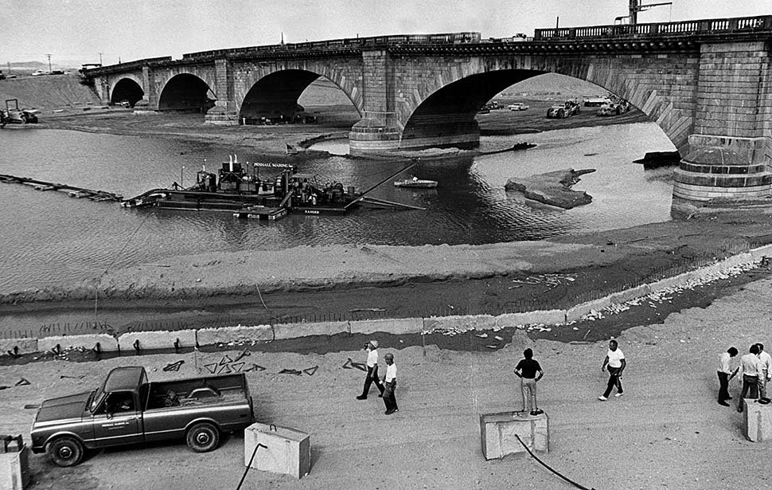
Lake Havasu City, home of the historic London Bridge, is situated on the eastern shore of Lake Havasu on the Colorado River border of California and Arizona. The City was established in 1963 by Robert P. McCulloch as a self-sufficient, planned community. McCulloch purchased the London Bridge for $2,460,000. Moving the bridge to Lake Havasu City and reconstructing it in the middle of a desert cost an additional $7 million. The bridge was dismantled and shipped by boat from England to the United States and rebuilt on a peninsula on Lake Havasu. A channel was excavated under the bridge and an English Village replication was built next to it, with a welcoming and informative Visitor’s Center. The opening of the London Bridge in October 1971 brought a unique attraction to Lake Havasu City, which was incorporated in 1978.
Lake Havasu City is in Mohave County, Arizona, and encompasses 42 square miles with 428 miles of streets. Situated off Arizona Highway 95, an 18-mile drive north leads to Interstate 40, and a 65-mile drive south leads to Interstate 10.
Visitors are attracted to Lake Havasu City each year for its calm waters and beautiful beaches. The 45-mile-long Lake Havasu, formed by Parker Dam on the Colorado River, offers abundant attractions. The deep blue water with its coves and inlets makes the lake a good fishing spot.
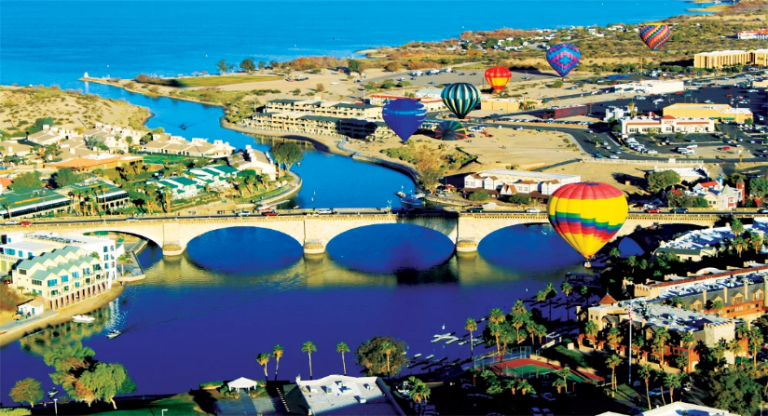
Lake Havasu is home to more lighthouses than any other city in the U.S. These 1/3 scale replicas are actual functioning navigational aids built to the specifications of famous east and west coast lighthouses. More than twenty of them can be seen on the shores of the lake.
Lake Havasu City offers a broad range of community facilities including an airport, regional parks, and amenities, two movie theater complexes, a library, an aquatic center and a historical museum.
The City is proud to be the home of a shopping mall, The Shops at Lake Havasu, which opened in 2008 with over 720,000 square feet of commercial space available. The mall is anchored by Dillard's, J.C. Penney's, and Super Walmart. Additional shopping can be found in the Channel Riverwalk District and the Uptown McCulloch Main Street District which also is host to many special events throughout the year. Unique

boutiques, salons, night clubs, restaurants, and performing arts facilities can be found throughout the community.
Lake Havasu City has a hot desert climate. In the winter months, daytime highs usually range from 60 ° to 70 °. The city has extremely hot summers, with highs normally remaining between 100 ° and 115 °, but highs are known to exceed 120 ° during the summer months.
Lake Havasu City is served by six elementary schools, one middle school, one high school, and several alternative schools in the city: Mohave Community College, Northern Arizona University extended campus, and Arizona State University 4-year college campus.

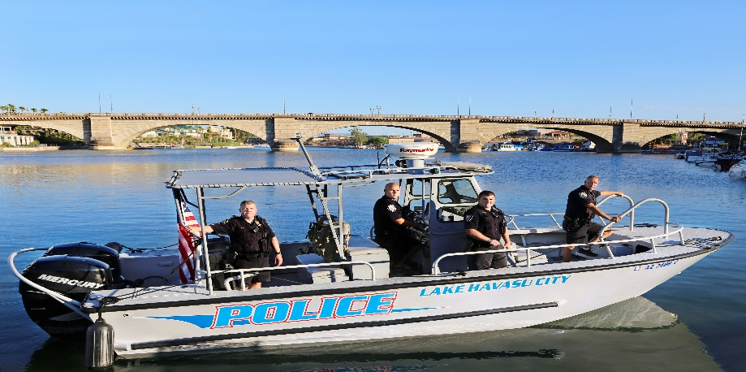

Lake Havasu City Named One of Three Top Rural Communities of America’s Best Competition
In April 2017, the city was named “America’s Best”, one of the top three rural communities in America! Lake Havasu won $2 million for its second-place finish in the America’s Best competition. Launched to inspire revitalization and growth in small towns and rural communities across the country, it challenged local leaders to bring their neighbors together to envision a stronger future and build a strategy to improve lives and livelihoods.

The $2 million prize accelerated implementation of the city’s Vision 20/20 plan, which focuses on five pillars: economic development and job creation, education and workforce talent, tourism development, water preservation and management, and community engagement.

W.A.L.E.A
WESTERN ARIZONA LAW ENFORCEMENT ASSOCIATION
The Western Arizona Law Enforcement Association was organized in 2006 with membership of all law enforcement agencies in Mohave and LaPaz County. The group has grown to include all of Yuma County and California law enforcement agencies. The original goal was to form a training consortium for in-service officer training. WALEA has offered numerous training courses reaching hundreds of officers throughout Western Arizona.

W.A.L.E.T.A
WESTERN ARIZONA LAW ENFORCEMENT TRAINING ACADEMY
In 2007 the group expanded their training opportunities by opening WALETA. The academy, located here in Lake Havasu City, was the first regional training academy for Western Arizona. The academy has gained recognition throughout the state and recently graduated their 33rd class of new police officers. The academy has expanded their dormitory capacity, added two mobile classrooms, and added a satellite building to house a state-of-the-art firearms simulator and defensive tactics room.
In 2011 WALEA expanded training opportunities with the development of the first Dispatch Academy in the State of Arizona. The academy is held twice a year with a 3-week curriculum that provides APCO, EMD, CPR, ACJIS and NIMS certifications.
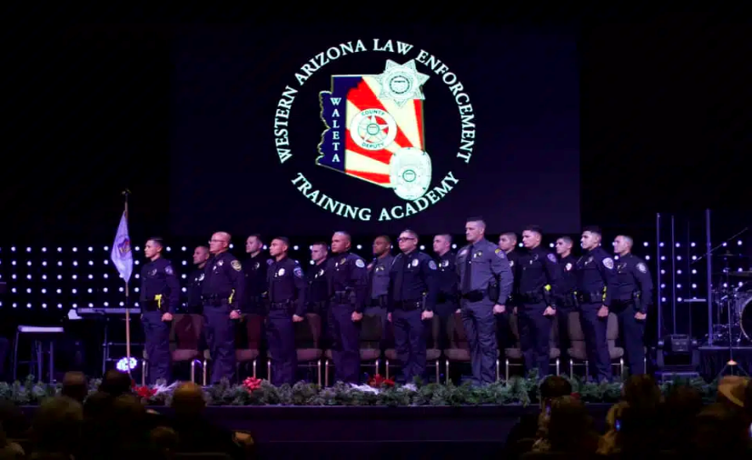


M.A.G.N.E.T
Mohave Area General Narcotics Enforcement Team
Lake Havasu City Police Department’s Special Investigations Unit (SIU) is primarily responsible for investigating narcotic and prostitution-related crimes. The SIU is an active part of the MAGNET task force and collaborates with other Mohave County law enforcement agencies to suppress illegal sales and distribution of controlled substances on a regional and national level.

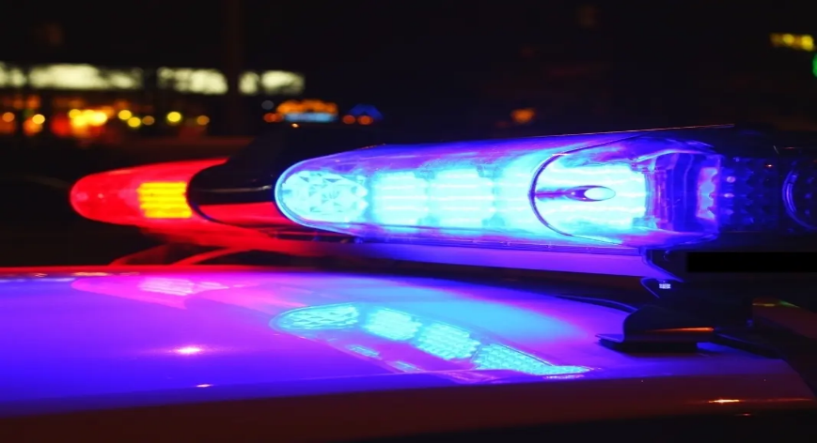

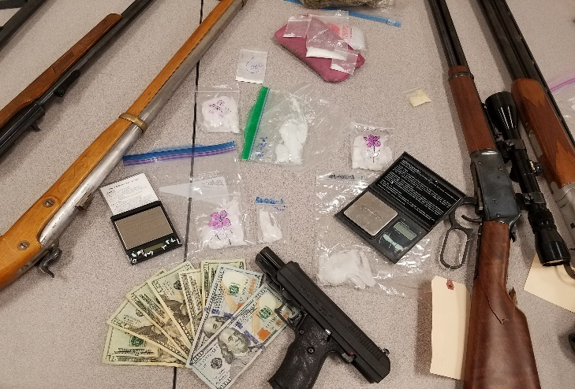



News
2330 McCulloch Boulevard North
Lake Havasu City, AZ 86403-5947

www.lhcaz.gov

FOR IMMEDIATE RELEASE
Date: December 22nd, 2023

Accreditation Assessment Team Invites Public Comment

The Lake Havasu City Police Department is seeking re-accreditation through the Arizona Association of Chiefs of Police (AACOP) Arizona Law Enforcement Accreditation Program (ALEAP). Accreditation is a progressive and time-proven method of assisting law enforcement agencies in measuring and improving their overall performance. ALEAP is intended to provide law enforcement agencies in the state with an avenue for demonstrating that they meet commonly accepted best practices and industry standards for efficient, effective, productive and quality operations. The Lake Havasu City Police Department was proudly accredited (initially) in 2020.

A team of assessors from ALEAP will arrive on January 3rd, 2024, to examine all aspects of the Lake Havasu City Police Department policies and procedures, management, operations, and support services.

“Verification by the team that the Lake Havasu City Police Department meets the Arizona Law Enforcement Accreditation Commission’s “best practice” standards is part of a voluntary process to achieve accreditation, a highly prized recognition of law enforcement professional excellence”, Chief Troy Stirling said.

As part of this final On-Site Assessment, employees and members of the general public are invited to provide comments to the Assessment Team. They may do so by telephone or email. The public may call (928) 854-0854 on January 3rd, 2024, between the hours of 3:00 P.M. – 4:00 P.M. Email comments can also be sent to kevin.rhea@azchiefsofpolice.org.

Telephone comments are limited to five (5) minutes and must address the agency’s ability to comply with the Commission’s standards. These standards can be found online at www.azchiefsofpolice.org/aleap-accreditation-program.

Additionally, a copy of the standards is available for inspection at the Lake Havasu City Police Department, 2630 McCulloch Blvd., N. Lake Havasu City, AZ 86403. Please contact Lieutenant Chad Williams, Accreditation Manager at (928) 855-1171.

Anyone wishing to offer written comments about the Lake Havasu City Police Department’s ability to comply with the standards for accreditation is requested to email the Accreditation Manager at williamsc@lhcaz.gov, or write the Arizona Law Enforcement Accreditation Program at 75 E. Civic Center Drive, Gilbert, AZ 48296.

The Lake Havasu City Police Department must comply with 174 standards in order to achieve accredited status.

Police Chief Troy Stirling indicated, “Accreditation results in greater accountability within the agency, reduced risk and liability exposure, stronger defense against civil lawsuits, increased community advocacy, and more confidence in the agency’s ability to operate efficiently and respond to community needs.”

The Accreditation Program Manager for ALEAP is Kevin E. Rhea. “The assessment team is composed of law enforcement practitioners from similar Arizona law enforcement agencies. The assessors will review written materials, interview agency members, and visit offices and other places where compliance with the standards can be observed. Once the assessors complete their review of the agency, they will report to the full Commission, which will then decide if the agency is to be granted accredited status”, Rhea stated.

Accreditation is valid for a four-year period during which time the agency must submit annual reports attesting to their continued compliance with those standards under which it was initially accredited.

The Arizona Association of Chiefs of Police (AACOP), is the accrediting agency in the State of Arizona. For more information regarding the Arizona Association of Chiefs of Police, please visit www.azchiefsofpolice.org.

Public Information Officer: Sergeant Mike Terrinoni (928) 855-1171

-- END --
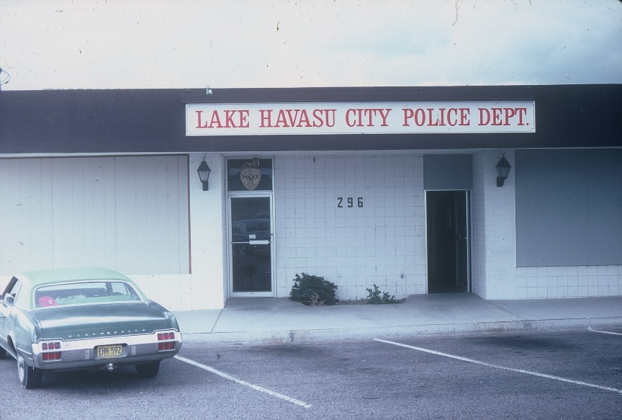
Lake Havasu City Police Department
The Lake Havasu City Police Department was commissioned on July 1, 1979, and began with fourteen police officers under the direction of Arizona’s only female police chief, Police Chief Shirley Bassford. The first patrol shift was conducted in a borrowed car and temporary office space from the fire department at 145 North Lake Havasu Avenue. Officers were dressed in desert rose colored uniform with a forest green stripe down the outside of each leg. The leather gear was a dark brown basket weave with ox blood-colored boots.
When the Department started in 1979, the population was nearly 14,000 residents, the dispatch center was located at Fire Station #1 on Lake Havasu Avenue and the police department was in a borrowed office there for the first few days. The first official police department was located upstairs in the same building as the courthouse at 2060 W. Acoma Boulevard. The Police Department occupied the first half of the building upstairs, Probation and MCSO occupied the second half of the building. There were two jail cells next to the MCSO section of the building. The prisoners had to be walked up the stairs to be placed in the cells.
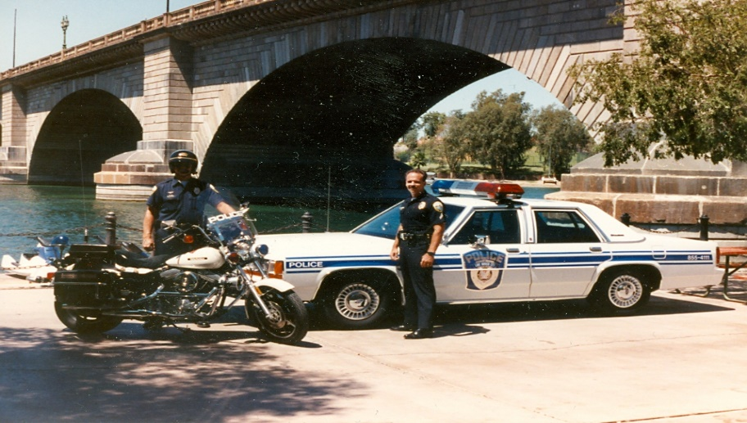
The Department moved again the following year and then in April, 1994 moved to its current location, 2360 N. McCulloch Blvd.
Today, the Department has 135 employees, 84 sworn and 51 non-sworn, that provide service to a community in excess of 57,000 residents. The Lake Havasu City Police Department consists of two divisions: Operations and Support.

OPERATIONS DIVISION
The Operations Division is comprised of all patrol, specialized and investigative units of the Police Department. The Operations Division Captain leads three Lieutenants who manage dayshift and nightshift patrol, the Street Crimes Unit, Criminal Investigations Unit and Special Investigations Unit.
The Dayshift Patrol Lieutenant oversees two patrol squads, the Traffic Unit, and our Community Services Unit (School Resource Officers, Animal Control, Watercraft and Special Events, Neighborhood Watch and our Volunteer Program).
The Nightshift Lieutenant oversees two patrol squads, the Street Crimes Unit, and the SWAT team.
The Investigations Lieutenant oversees the Criminal Investigations Unit (General crimes including crimes against persons and children, property crimes, financial crimes and other incidents requiring in-depth investigation) and the Special Investigations Unit (Narcotics and vice).

PATROL BUREAU
The function of the patrol bureau is the protection of the lives and property of the citizens of Lake Havasu City, maintaining the public order, preventing and deterring crime through uniformed appearance and responding to calls for service.
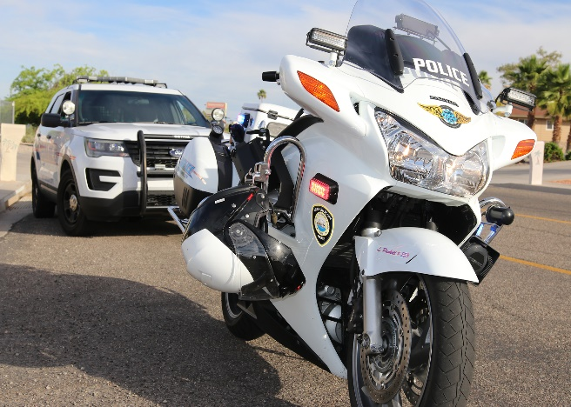
The patrol bureau is made up of four patrol squads of officers who are supervised by four sergeants. The Traffic Unit, Community Services Unit and the Street Crimes Unit also fall under the Patrol Bureau. The patrol officers engage in a wide variety of activities such as crime prevention, responding to calls for service, investigation of crimes, traffic accidents and direction, maintaining public order, emergency services, development of good relationships with citizens, and reporting to appropriate entities. Patrol officers shall thoroughly investigate and document incidents, and arrest violators for violations of city ordinances and state statutes. The patrol bureau is considered the front line of the Police Department and is the only function, other than The Dispatch Center, that is working 24 hours a day, seven days a week, 365 days a year.

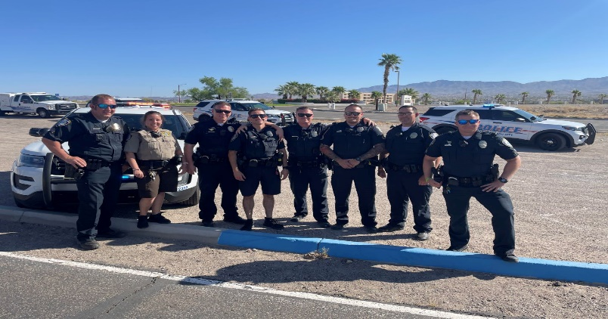
The patrol bureau encourages cooperation, communication, and coordination, to accomplish the department mission of Ensuring a safe and secure community.

Traffic Unit
The Traffic Unit ensures safe roadways for the citizens of Lake Havasu City by reducing traffic crashes through engineering, education, and enforcement.
Street Crimes Unit
The Street Crimes Unit (SCU) is a proactive policing unit which monitors crime trends and investigates street level criminal activity. They also monitor all city liquor licenses and liquor establishments.
Members of SCU also liaise with school/youth officers and assist with youth and gang issues as they arise. They also liaise with other law enforcement agencies including Probation, other Police Agencies, and Immigration Officials and assist in locating and arresting wanted persons.
The Street Crimes Unit is under the direction of a sergeant.
Community Services Unit
The Community Services Unit consists of a sergeant that supervises 3 boating officers, 2 School Resource Officers, 2 Animal Control Officers, and a Neighborhood Watch Coordinator.
The boating unit patrols the Bridgewater channel and several miles of shoreline within Lake Havasu City. The boating officers work closely with other law enforcement agencies in the area that include the Mohave County Sheriff’s Department, San Bernardino County Sheriff’s Department, US Fish and Wildlife Service, Bureau of Land Management, and Arizona Game and Fish Department.
School Resource Officers (SROs)
Cover law related issues that occur at any school within Lake Havasu City. The SROs utilize both proactive and reactive community policing methods in dealing with educational institutions. The SROs foster a positive relationship with students and staff to further the goals of the police department and educational institutions.

Animal Control Unit
provides the residents of Lake Havasu City with professional animal control services. The unit consists of two Animal Control Officers supervised by a sergeant.

Neighborhood Watch Coordinator oversees the Neighborhood Watch Program, which consists of all residents who are part of the 96 watch groups within Lake Havasu City.

INVESTIGATIONS BUREAU
The Investigations Bureau encourages cooperation, communication, and coordination, to accomplish the department mission of Ensuring a safe and secure community.

Criminal Investigations Unit (CIU)
The Criminal Investigations Unit (CIU) investigates a wide variety of crimes including homicides, aggravated assaults, sexual offenses, child-related crimes, fraud, burglary, and theft. This unit is also responsible for investigating unattended deaths and missing persons, as well as officer involved shootings in neighboring cities. Detectives assigned to the CIU receive extensive training in their assigned specialties.
Crime Scene Specialist
The Crime Scene Technician (CSS) responds to crime scenes to document, locate, and recover evidence through a variety of methods, including fingerprinting, photography, crime scene reconstruction, and gunshot trajectories. The CSS is an integral member of the Investigations Bureau and provides valuable support to detectives investigating major crime incidents in Lake Havasu City. When called upon to do so, the CSS may provide expert testimony in court proceedings. In addition to attending ongoing training, the CSS is responsible for the acquisition of both standard and specialized forensic science equipment that enhance investigative capabilities.

Special Investigations Unit (SIU)
The Special Investigations Unit (SIU) is primarily responsible for investigating narcotic and prostitution-related crimes. The SIU is part of the Mohave Area General Narcotics Enforcement Team (MAGNET) task force and collaborates with other Mohave County law enforcement agencies to suppress illegal sales and distribution of controlled substances on a regional and national level.

SPECIALIZED UNITS

SWAT Team
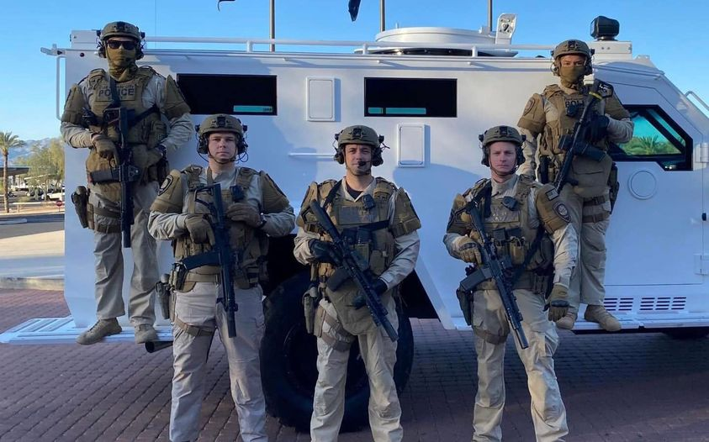
The Lake Havasu City Police Department’s Special Weapons and Tactics (SWAT) is a team of specially trained police officers, which will respond to any incident where special weapons and tactics are needed within the city or other jurisdictions as authorized by the Chief of Police.
The unit consists of highly trained personnel with specific skills in the areas of marksmanship, tactical response and containment, emergency medical response, and hostage/crisis negotiations. LHCPD SWAT is under the direct supervision of a unit commander and a team leader.
The purpose and intent of LHCPD SWAT is to serve as a specialized, flexible, and mobile unit, activated to assist the department in the containment, de-escalation, and ultimate control of all situations beyond the capabilities of today’s police officer.

DIVE Team
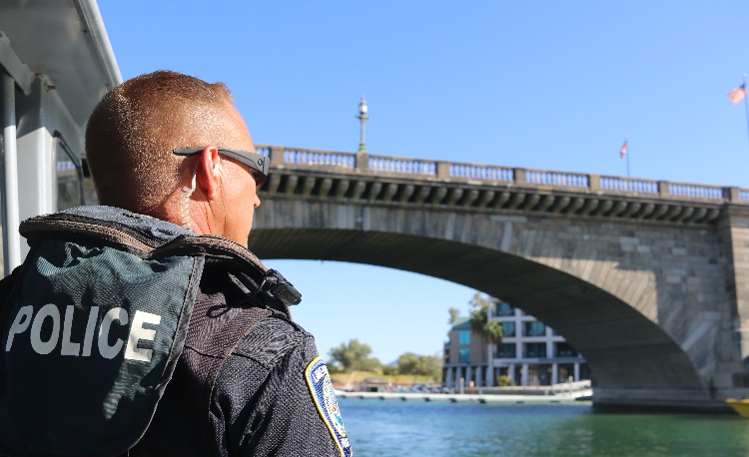
The Lake Havasu City Police Department Dive team consists of 4 sworn officers with one being a master scuba dive trainer, who is responsible for all training and the proper execution of all dive missions. Each member of the team is required to complete advanced open water certification through one of the world recognized training programs of PADI, NAUI, or SSI. Team members are also required to pass annual evaluation testing, which includes the proper execution of various underwater skills, as well as the completion of rigorous physical fitness requirements.
The Dive team's primary function is the search and recovery of drowning victims, evidence, and property. However, the team now has one-piece portable SCUBA units which can be operational within seconds. These portable units can be carried on board at least one of the agencies patrol boats during the boating season, possibly reducing the team’s response time to a few minutes. With these portable units this transformed recovery dives into rescue dives.

UAS Team
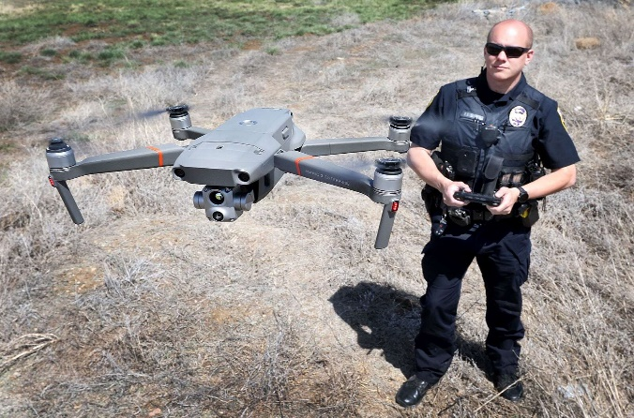
In 2021 the police department implemented a UAS (Unmanned Aerial System) program. Our team consists of eight member pilots that include the team supervisor. Our pilots utilize a fleet of drones to conduct aerial surveillance and provide assistance with obtaining real-time intelligence critical for search and rescue missions, disaster response, and surveillance details. Our team is also utilized for crime scene reconstruction, traffic collision reconstruction, special events as well as agency assistance requests.

SUPPORT SERVICES DIVISION
The mission of the Support Services Division is to provide all civilian and sworn personnel of the Lake Havasu City Police Department with the resources required to effectively perform their assigned duties and to enhance the capabilities of the department. Each section within the Support Services Division is an integral part of the planning and management of a broad range of services provided to the organization and falls under the supervision of the Support Services Division Captain. The Division consists of the Professional Standards Unit, The Dispatch Center, Records Unit and Jail Operations.

PROFESSIONAL STANDARDS UNIT
The Professional Standards Unit is comprised of one sergeant, one detective and a background investigator who reports directly to the Administrative Lieutenant. The Professional Standards Unit is responsible for:
- Conducting background investigations on applicants to ensure we hire individuals whose core values reflect those of the Lake Havasu City Police Department.
- Conducting internal misconduct and other administrative investigations.
- Managing the department's administrative investigation records.
- Coordinating department training and maintaining training records.
- Conducting internal audits on processes and procedures.
- Any other projects assigned by the Chief of Police.

PUBLIC SAFETY DISPATCH CENTER
The Dispatch Center and Records Unit are managed by the Support Services Lieutenant. The Dispatch Center is typically staffed with a 2 Dispatch Supervisors and 11 Dispatchers. The Dispatch Center dispatches for the Fire Department and Police Department, to include Animal Control. Total calls received equal approximately 10,000 phone calls per month (9-1-1 and non-emergency), resulting in over 4000 police, 700 fire/medical, and 5,300 police/fire department inquiries. The Dispatch Center is also responsible for answering all after hours calls for the city including the Water Department, Street Department, Parks Division, and Wastewater Division. The Dispatch Center also provides TDD service for the hearing and speech impaired, and it has the ability to connect with a language line to provide translation for over 170 languages. In April of 2017, the Lake Havasu City Dispatch Center became the first in the state of Arizona to receive text to 9-1-1, allowing citizens, who are unable to call, the ability to access emergency services.
A Public Safety Dispatcher is the critical link between the community and units in the field. Dispatchers are here to serve citizens and help first responders ensure a safe and secure community. From the greatest of disasters to the most basic of questions, dispatchers are just a call away any time of day or night.

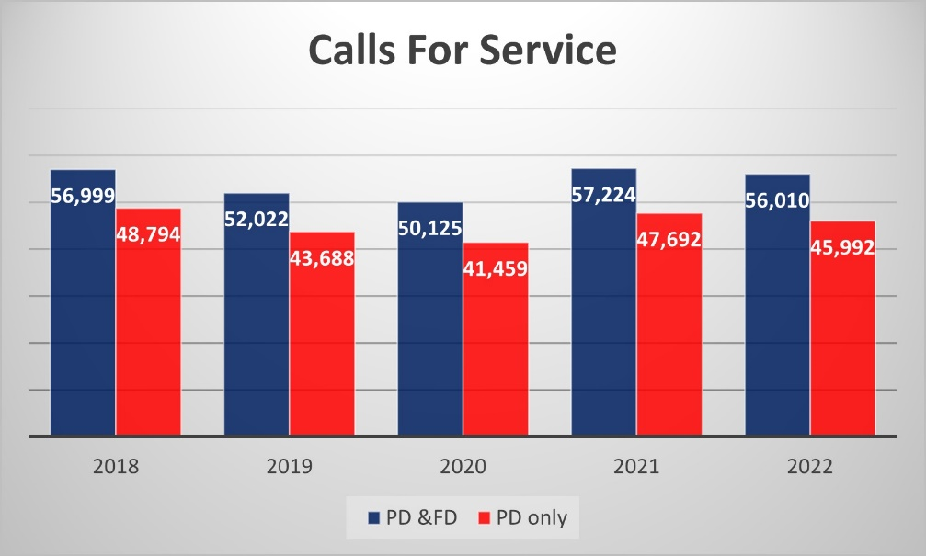

RECORDS UNIT
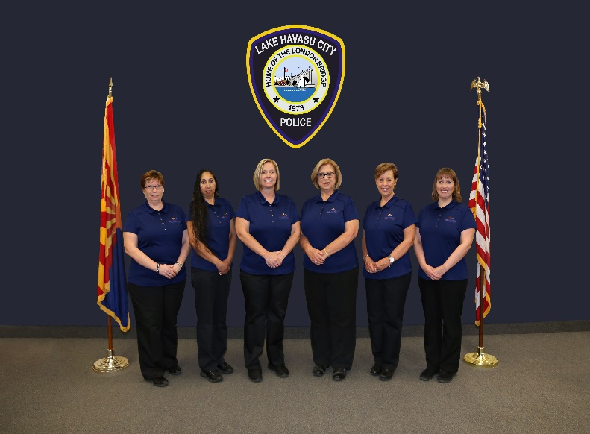
The Records Unit is a focal point for all other areas of the department. Information is collected and recorded here. National, State and Local statistics are disseminated from the Records Unit.
Hours of operation are 7:00 a.m. to 6:00 p.m. Monday through Friday and 7:00 a.m. to 5:00 p.m. on Saturday and Sunday. Staffing of the Records Unit is currently comprised of 8 positions - a records Supervisor and 7 records clerks.

JAIL UNIT
Holding Facility
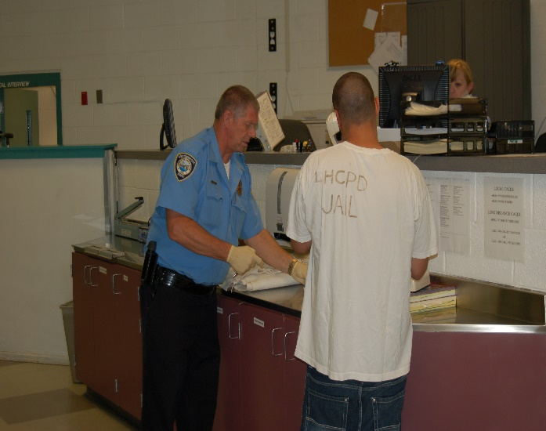
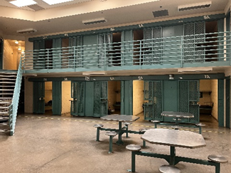
Lake Havasu City Police Department's prisoner process and 24-hour holding facility is located within the Police Department. The holding facility has 50 single-bunk housing cells, inmate dormitory with 16 beds, two temporary holding cell areas, and state-of-the-art computerized fingerprinting equipment. Detention Officers book, process, monitor and house, and transport prisoners daily.

Staffing for the Jail Unit is currently comprised of a Jail Unit Supervisor and 8 detention officers.

